|  |  |
| --- | --- |
|  | **YEAR 12 MATHEMATICS SPECIALIST**  **SEMESTER ONE 2017**  **TEST 2: Functions** |

Name: _______________________

Monday 3rd April

**Time: 50 minutes Mark /40 = %**

* Answer all questions neatly in the spaces provided. **Show all working.**
* You are permitted to use the Formula Sheet in **both** sections of the test.
* You are permitted one A4 page (one side) of notes in the calculator assumed section.

**Calculator free section Suggested time: 30 minutes /26**

1. [9 marks]

Two functions *f* and *g* are defined by  and 

* 1. Express  in terms of *x*

[1]

* 1. What is the natural domain of 

[2]

* 1. What is the range (co-domain) of 

[2]

A third function  is such that .

* 1. Express  in terms of *x*.

[1]

* 1. Clearly define  and specify both its domain and range.

[3]

1. [7 marks]
   1. Solve the inequality 

[3]

* 1. Calculate where the line  intersects  and illustrate your solution on the axes provided.

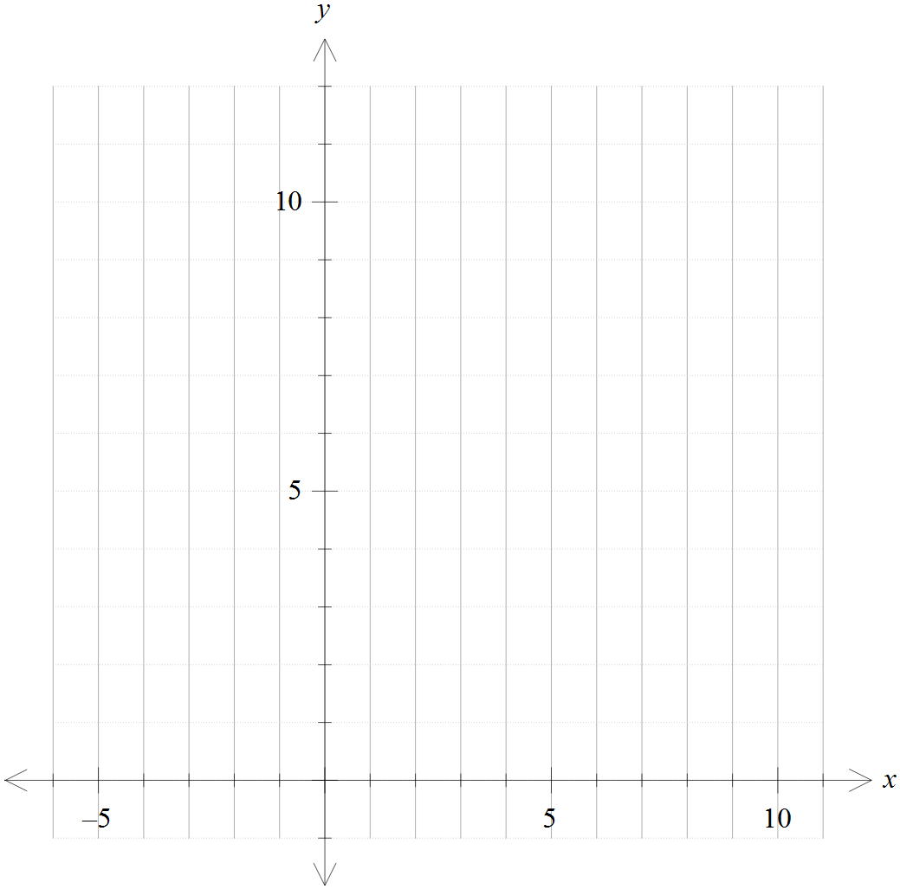

[4]

1. [10 marks]

The function  is represented by the graph of  shown on each set of axes provided.

* 1. 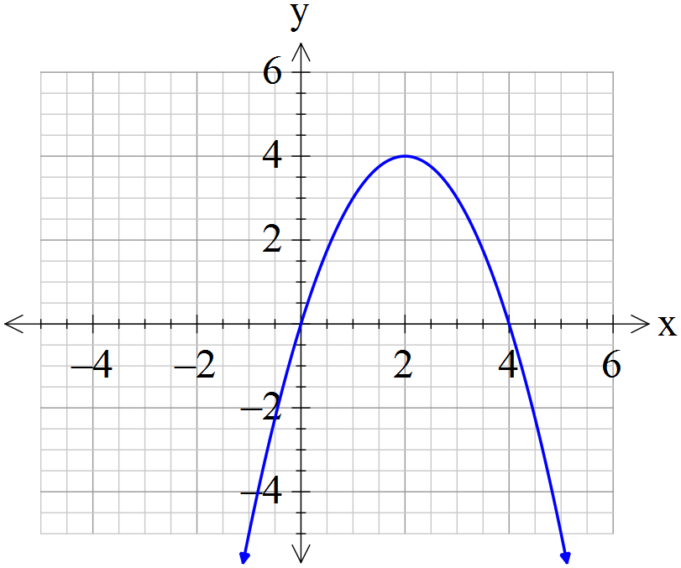Draw ,  and  on these separate diagrams:



[4]

The domain of  is restricted to  so that  can be defined as a function.

* 1. Determine the largest possible value of *k*

[1]

* 1. Define and specify its domain and range.

[5]

**Calculator assumed section Suggested time: 20 minutes /14**

Name: _______________________

1. 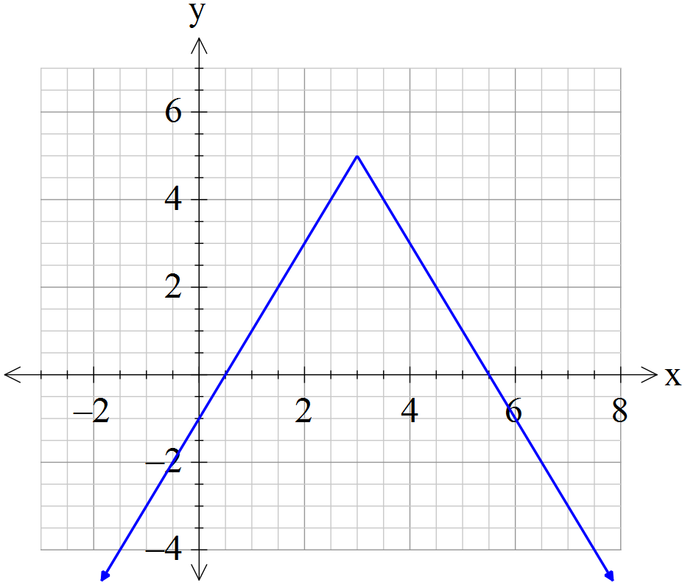[7 marks]

The graph of  for has a *y*-intercept of  and a maximum point at , as shown.

* 1. Evaluate *a*, *b* and *c*.

[3]

* 1. For which value(s) of *d* does  have exactly four solutions?

[2]

* 1. Add a graph of  to the axes above so that 

[2]

1. [7 marks]

This graph represents a function of the form 

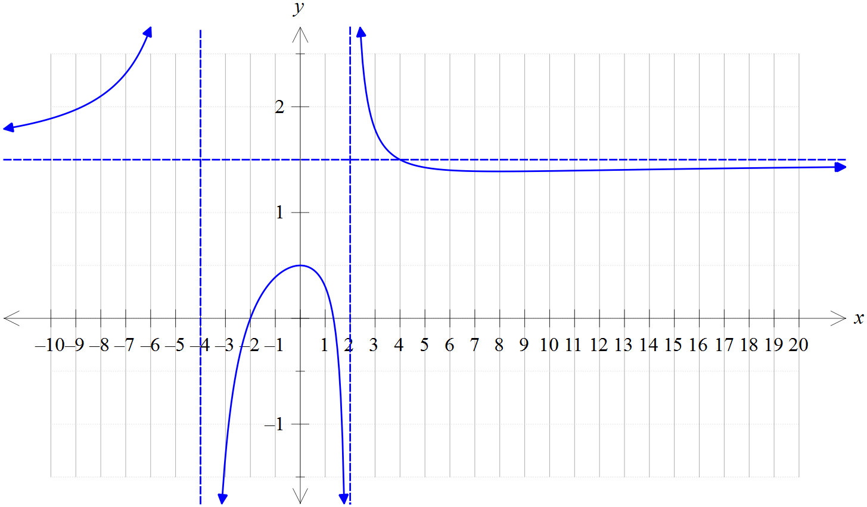

The asymptotes are as shown and the unmarked *x* intercept is .

* + - * 1. Determine the values of the constants *a*, *b*, *c* and *d*.

[4]

* + - * 1. What is the exact range of ?

[3]